**Experiment 10**

**Student Name:** Sahil Kaundal **UID:** 21BCS8197

**Branch:** BE CSE (Lateral Entry) **Section/Group:** 807/B

**Semester:** 4th **Date of Performance:** 17/05/2022

**Subject Name:** MPI Lab **Subject Code:** 22E-20CSP-253

1. **Aim/Overview of the practical:**

Find the smaller number in an data array.

**2. Task to be done/ Which logistics used:**

Find the smaller number in an data array.

**3. Apparatus / Simulator Used:**

1. Jubin Application

2. 8085 Simulator

3. JDK

**4. Algorithms/Flowcharts:**

* Find the smaller number in an data array.

1. Load the address of the first element of the array in HL pair.
2. Move the count to B - reg.
3. Increment the pointer.
4. Get the first data in A - reg.
5. Decrement the count.
6. Increment the pointer.
7. Compare the content of memory addressed by HL pair with that of A - reg.

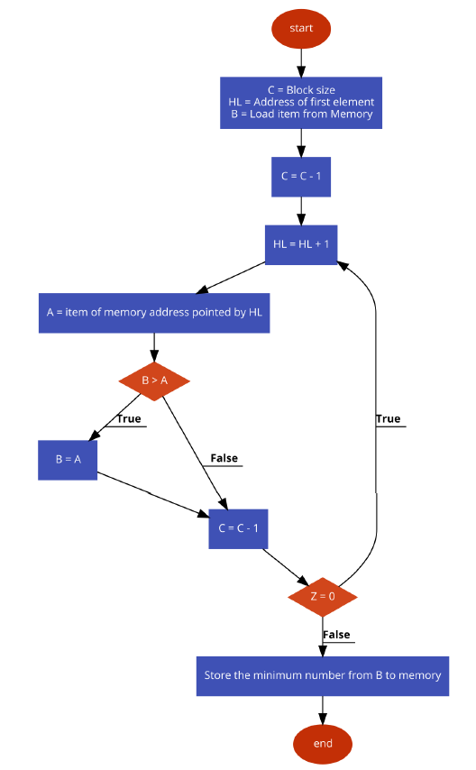

**5. Programs:**

* Find the smaller number in an data array.

# BEGIN 0000H

LXI H,5000

MOV B,M

INX H

MOV A,M

DCR B

LOOP: INX H

MOV A,M

AHEAD: DCR B

JNZ LOOP

STA 6000

HLT

**6. Result/Output/Writing Summary:**

* Find the smaller number in an data array.

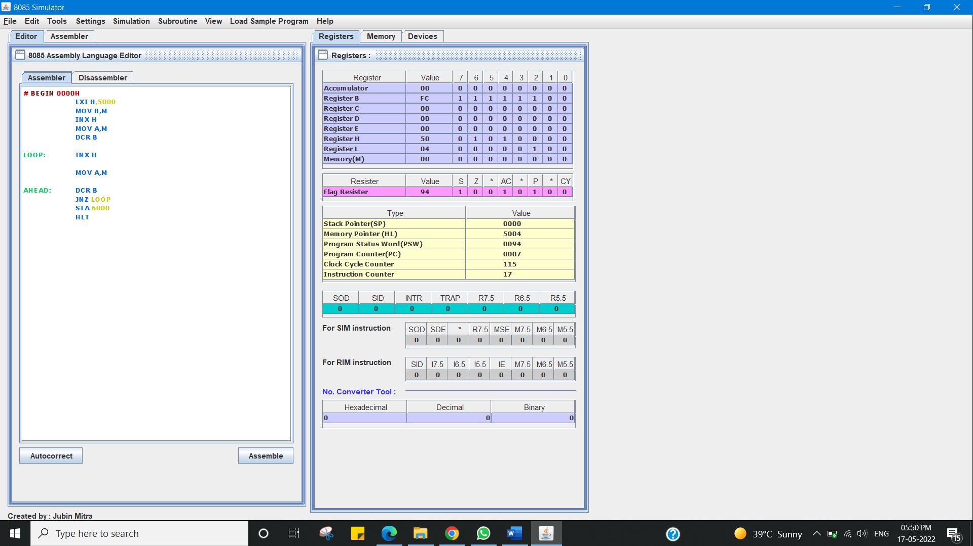

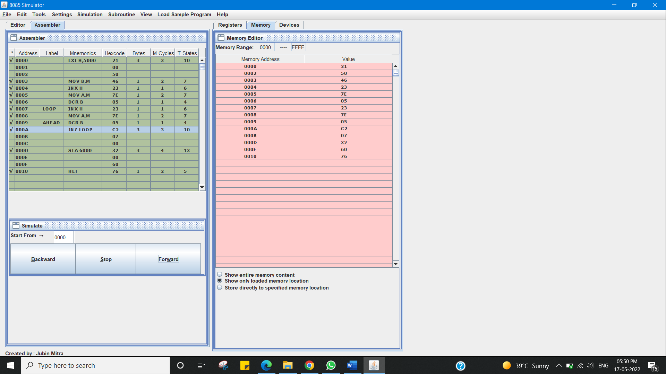

**Learning outcomes (What I have learnt):**

1. Working of microprocessor.

2. Learn how to complement data in microprocessors.

3. Learnabout8085simulator.

4. Operationsof16-bit numbers.

5. Learn about the different instructions that are needed to be given to the memory to perform some tasks.

**Evaluation Grid (To be created as per the SOP and Assessment guidelines by the faculty):**

|  |  |  |  |
| --- | --- | --- | --- |
| Sr. No. | Parameters | Marks Obtained | Maximum Marks |
| 1. |  |  |  |
| 2. |  |  |  |
| 3. |  |  |  |
|  |  |  |  |